PWA video 10 Activate Event

<https://www.youtube.com/watch?v=AmWj52zw9R8>

Next the service worker fires an active event

This happens automatically the **first time** a service worker is registered and then installed in the browser.

There after anytime the SW is changed and it is re installed we have to do something else to activate the service worker and fire the active event.

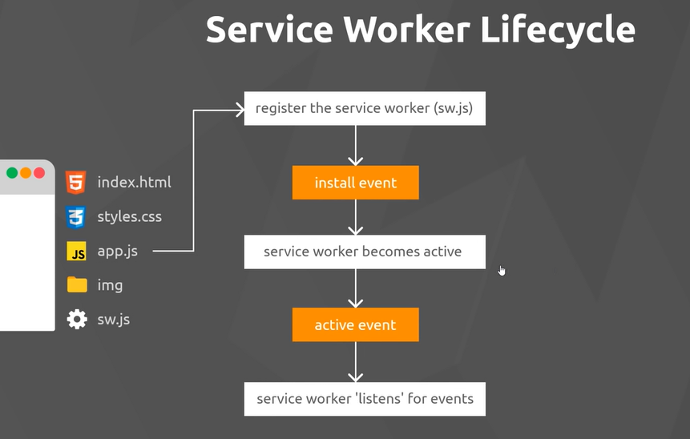

When we re install a SW ( when file changes) it very briefly changes to ‘in waiting”

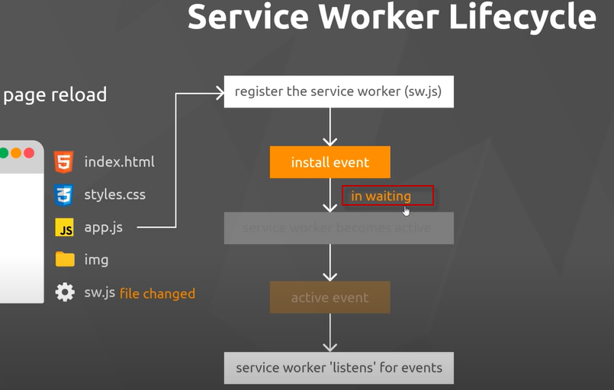

To delete the service worker from the browser got to chrom dev tools , application and un register

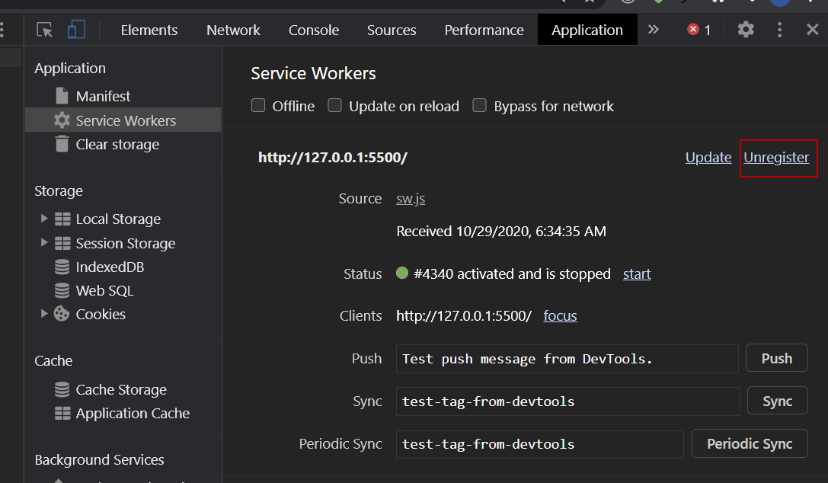

On refresh the activate and install are not re run but the registration is

Restart at 4 min in